Project result no. 2
Training course entitled:
Key competences for people 50+:
Literacy
Part 5/5 - Tools for validation of learning outcomes

Version: English

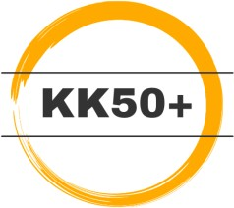
Prepared by the Project Consortium (main Author: MiA)
within the project 2021-1-PL01-KA220-ADU-000035200, „Key competences for people 50+”
The project implemented under the Erasmus+ program, from 1 February 2022 to 30 November 2023 by the consortium: Deinde sp. z o.o. (Poland), Institut Saumurois de la Communication (France), INERCIA DIGITAL SL (Spain), Stiftelsen Mangfold i Arbeidslivet (Norway).
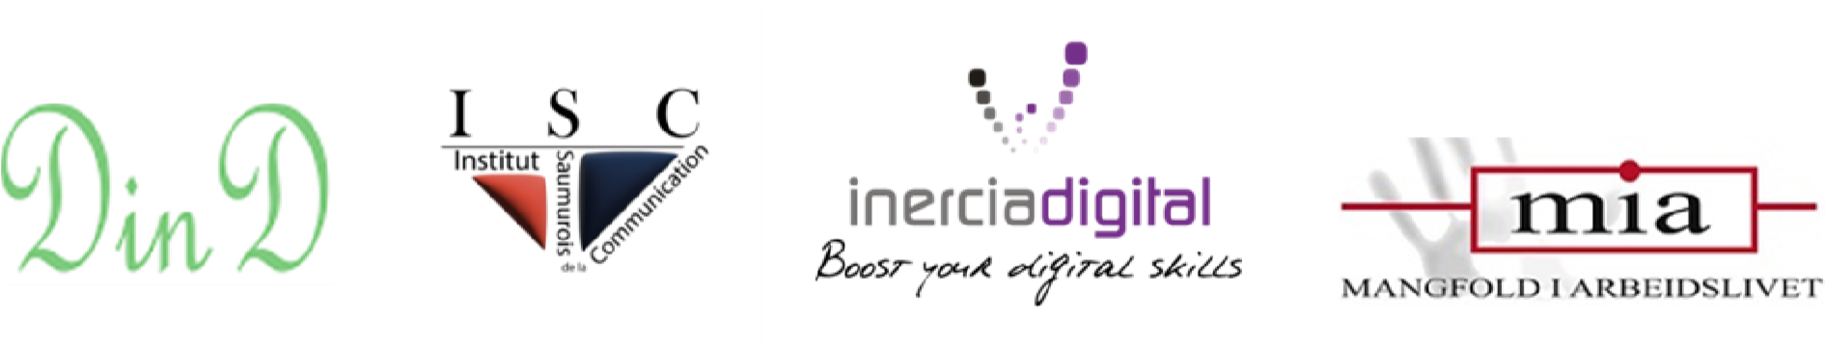
Disclaimer: Funded by the European Union. Views and opinions expressed are however those of the author(s) only and do not necessarily reflect those of the European Union or the European Education and Culture Executive Agency (EACEA). Neither the European Union nor EACEA can be held responsible for them.

Tools for validation of learning outcomes

Kahoot!-quiz
Guidelines and questions for the Kahoot!-quiz

The trainer needs an access to a Kahoot! quiz game account, a user profile can be set up here: www.kahoot.com
The classroom should have a decent Wi-Fi access and a screen. The participants need smartphones/tablets/computers to access the game. If these are unavailable, the analogue implementation (pen & paper) is a valid option.
The access to the free version lets you use two question formulas – four alternatives or true/untrue. When filling in the quiz, the time frame for answering each question should be set to at least 1 minute for the four alternatives and 30 seconds for the true/untrue questions. The trainer should also ask if the participants wish the questions to be read aloud.
In addition to the results and the podium seen immediately after paying the game, Kahoot! generates a detailed report of the results afterwards. This report highlights problem areas for the group as a whole and gives insight in how individual players did during the game and which questions were especially challenging for them and the whole group.

Question 1 – four alternatives (the correct alternative is marked with X)
When is an informal approach to language advisable?

A motivational speech at a youth camp. X
An eulogy at the funeral service.
A letter to your local political representative.
A job interview.

Question 2 – four alternatives
Which sentence has correct language?

Anna and Amina have refurbished they’re apartment recently.
Their going to sell the apartment soon.

I saw they’re car parked outside the office building.
They’re visiting their real estate realtor to discuss the sale. X

Question 3 – true/untrue
Oral contracts can be binding.
True X
False

Question 4 – four alternatives
Which of the statements is incorrect?

The private sector is funded by taxes. X
NGOs are not a part of the public sector.
The public sector offers services to citizens.
Charities belong in the third sector.

Question 5 - true/untrue
Body language is universal.

True
False X

Question 6 – four alternatives
How would you sign off a professional e-mail?

Yours truly
Just with my name
Kind regards X
Have a blessed day

Question 7 – true/untrue
When you write to the authorities, you can expect to receive an answer

True X
Untrue.

Question 8 – true/untrue
You should avoid “I” sentences in a disagreement

True
Untrue X

Question 9 – four alternatives
One of these is correct information (concerns English)

The first letter in weekdays, countries and verbs is written in uppercase.
The first letter in languages, cities and names is written in uppercase. X
The first letter in objects, animals and months is written in uppercase.
Lakes, rivers and mountains are written with only lowercase letters.

Question 10 – four alternatives
Are we done now? (or any lighthearted question of something that has happened in the classroom during the course)

We are never done with literacy! X
Yes, time for a break! X
Time is just an illusion! X
Yes, we need coffee! X

Self-assessment tool

How would you describe your prior knowledge and experience with today’s subject? Do you have a concrete example, or a story you’d like to share?

What do you expect/wish to learn today (learning objectives)?

Do you think today’s subject will be useful for you? If yes, how?

What have you learnt today? Name three concrete examples:

How would you describe your current skills and knowledge about today’s subject?

Were the lessons sufficient for you to reach your learning objectives or is there something you’d like to repeat or learn more about?

Do you think what you learned today will be useful for you? If yes, how?

Trainer’s observation log
*This document is intended as an example template on how the trainer’s log for documentation of the individual learner’s learning process during the literacy course can be constructed and used*.
Participant 1 (name here)
Initial level of key competence, the trainer’s assessment of the texts produced in the beginning of the course, both strengths and areas for improvement
Date for testing: xx.xx.xx
- Orthography: note challenges with punctuation, homophones (words that sound the same, but are written differently) and spelling in general here
- Vocabulary: note if certain words are repeated often, pay attention to the use of synonyms and expressions etc.
- Grammar: note any difficulties with correct sentence structure and conjugations.
- Style: note the tendency to the use of spoken language, dialect or slang in the text
- Coherency: pay attention to the coherency and comprehensibility of the text and note your observations here.
Other observations of written and oral literacy skills:
Modules:
Under each module you can describe how the learner has developed their knowledge, skills and attitudes. Note also comments or wishes the learner has about the course.
Module 1 – date: xx.xx.xx [an example of a log entry}
(Name) has learned how to write invitations, informational posters and simple meeting summaries. Some problems with homonyms. They have received additional assignments to help them with distinguishing “they’re” from “their”. They have raised their awareness of the importance of correct written communication and is eager to learn more. Expressed interest in understanding insurance policies better. Areas for improvement: we will have to work more on reading comprehension, and punctuality in the class room (has taken extended breaks).
New items in the portfolio: An invitation to a birthday party, a meeting summary

Module 2 - date: …
(Name) has …
Module 3 – date:
…..
Module 4 – date:
…..

Module 5 – date:
…….
Final Assessment:
Based on the log, portfolio (text/video/other production) and the participant’s own feedback during the lessons, write a short summary here about how the learner’s knowledge, skills and attitudes have developed throughout the course. If the trainer chooses, they may include concrete examples in development of orthography – vocabulary – grammar – style – coherency in accordance of the initial assessment, if relevant for the overall context of the course. This individual assessment can then be used for a “road ahead” – conversation and as a basis for recommendations for further classes.
----------------------------------------
Participant 2 (Name here):
Initial level:
Modules:
Module 1:
Module 2:
Module 3:
Module 4:
Module 5:
Final assessment:
----------------------------------------------------------------------
Participant 3 – continue as above

